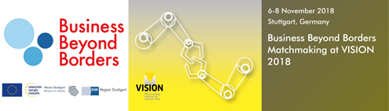

Photonik-Forum
Baden-Württemberg

Guided Tour &
International Business Matchmaking Event
Trade Show VISION 2018
Thursday, 8.11.2018

Dear participants of the Photonik-Forum Baden-Württemberg and DeepTech4Good,
we are very happy to welcome you to our event on 7.11.2018 in Stuttgart.
To enrich your visit to the Stuttgart region - one of the EU’s major manufacturing hubs – we would like to draw your attention to a special offer of our European activities:
A Guided Tour at the trade fair VISION 2018 on
8th November 2018 from 10:00 to 13:00
The trade show is the world’s leading fair for machine vision and thus a highly specific part of the photonics industry. A range of state-of-the art products and services are presented - from sensors to processors, from cables to cameras, from software to illumination systems. Complete machine vision systems and very specific applications for many different industries are exhibited – from mechanical engineering and the automotive industry through to the medical technology industry.
The tour includes the possibility to take part in the international business matchmaking event organized by the Chamber of Commerce and Industry (IHK Region Stuttgart) in collaboration with Business Beyond Borders (BBB), an initiative supported by the European Commission.
Companies can register for the Guided Tour on the business matchmaking platform https://vision2018.b2match.io without charge using the key word DEEPTECH4GOOD. Free tickets for the trade fair VISION are also available at the Photonik-Forum and at DeepTech4Good#Stuttgart.
In case of questions, please contact:

Thomas Bittner
IHK Region Stuttgart / Enterprise Europe Network
Tel. +49 711/2005-1230
E-Mail: thomas.bittner@stuttgart.ihk.de

